Research on the Security of Deleting Data
for Android File Manager

BinBin Li,JiangTao Liu,YiCheng Jin
Beijing Institue Of Technology
Beijing,China
Compiler2017@163.com

Abstract—With the rapid development of mobile Internet, intelligent mobile terminal has become one of the important carrier of personal privacy data. But for the current mobile smart terminal, the system provides data removal interface does not achieve the desired security. By using AOP slicing technology based on the Android system, we study the method of deleting data in various file managers existing in Android system. The research shows that some of these methods have serious security risks. We Propose a solution called PureEnc to protect data from Android devices against data retention issues.
Keywords: Android, data deletion, data residue, File Manager, AOP
Introduction (Heading 1)
The popularity of mobile smart terminal devices has changed the way people deal with personal information. More and more people choose to use mobile devices and other mobile devices to deal with personal affairs and work services. Mobile application developers offer a variety of programs to help people better manage the kinds of information used in their lives, such as using social applications to keep in touch with friends, using bank applications to handle their own banking transactions, Camera applications are used to record the moments of life. This trend makes the mobile smart terminal equipment contain more and more information closely related to the user's personal privacy data. As a result, personal privacy data leakage incidents occur more frequently. As the most popular mobile intelligent terminal operating system, in a very long period of time, Android is the main source of personal privacy data leakage occurred [1]. The main reason for this situation is that the Android system and applications for individuals have a security risk in the handling of privacy data, especially when the data deletion operation is performed, which does not satisfy the pre-conceived security. Although the problem of data residue on flash media [2] has been studied a lot, but in the Android system, this problem has still not got the attention from file system and operating system level. In the Android application development document, there is no special explanation for the problem or warnings for developers who use the general data interface to delete data about the existence of security issues, which led to the vast majority of Android applications are using unsafe data removal interface to handle sensitive data. This eventually leads to the occurrence of data leakage.

background
A. Android data storage
Different from traditional desktop computers, equipped with Android system, intelligent mobile terminals often choose flash memory as their own storage media. For flash memory, the most important feature is that all the data on the flash memory is written in blocks. In general, the size of a data block is a few hundred to several thousand bytes. When data deletion is performed, even if the data to be deleted is only part of a block, it is necessary to erase all the data on the entire block. Therefore, in order to improve the efficiency of disk read and write, when the data is deleted, the flash control chip will not really put all the data in the data block 0, but the data block is marked as unused. Later when other data is written into the data block, the so called “deleted data” is really erased. This results in the existence of the deleted data in the flash media for a period of time. The length of this period of time depends the size of the media and the frequency of disk read and write [3].

B. Data erase
In general, Android system has two main data erasure. The first is by calling the system API to delete the file directly, in this way to delete the file, its content will continue to remain on the disk. Through the full disk image extraction, you can get these residual data content, and then through some means of evidence can be restored to the original data content. In the Android system, the vast majority of data erase operations are in this way, although the interface in the system is not the same, but at the bottom of the system is to delete the file to delete Linux file. Android system, another data erase mode is to restore the factory settings, by triggering the system settings interface, Android system will restart to Recovery mode. In Recovery mode, the entire user data partition is automatically formatted. In general, the system will call the flash media interface to rewrite the entire partition, to ensure that all the data on the partition are safely erased.
C. Android data protection
Google, from Android 3.0, has been adding the choice of full disk encryption to Android system. Full disk encryption is modified based on Linux dm-crypt features. Users can choose to open the disk encryption for their own devices in the system settings. After all disk encryption is enabled, the user needs to enter the root key for decryption each time the system starts. Full disk encryption is a one-time irreversible process, which means that once the user has full disk encryption, unless the entire device is formatted, there is no other way to unlock the disk's encryption state.
In the Android system, in order to reduce the impact of full disk encryption on system performance, Google removed the dm-erypt program for all against the forensic security policy, which to some extent weakened the full disk encryption security. On the other hand, the on-the-fly encryption / decryption feature of the dm-crypt scheme determines that full disk encryption can’t confront attacks from within the system. When the system is already running, all data on the disk will no longer receive full disk encryption protection, with data access to any user and App can read the decrypted data. In the Android device root is very common today, full disk encryption and can’t effectively protect the security of disk data.
In addition, due to some flaws in the design of the program, resulting in full disk encryption did not bring the expected security. The full disk encryption key in the Android system is generated by the user's lock screen PIN, and the encryption parameters required to encrypt and decrypt the disk are stored in the crypto footer structure at the end of the corresponding partition of the local disk. By parsing this structure, an attacker can get the parameters needed to initiate a violent exhaustive attack on a disk that is protected by full disk encryption, that is, an exhaustive PIN. At the same time, as a daily use of handheld devices, the vast majority of Android users will not use too complex PIN to lock their phone. So for the Android default 6-bit PIN, any ordinary home computer can be completed within 1 to 2 hours to crack, and if you use a professional large computer to attack, crack the PIN range will be greatly improved.
These insecure features of full disk encryption are greatly amplified under the influence of disk data residue. For Android devices that are abandoned or accidentally lost, even if full disk encryption is turned on, attacker can still use the remaining disk Data to carry out the above attacks. and even found in the use of third-party recovery of the equipment, due to the lack of recovery developers, you want to format all the disk has become very difficult to become encrypted. And it’s found in some of the use of third-party recovery of the equipment, due to the recovery of the developer's negligence, format all disk encrypted disk has become very difficult.
To attack a device that has full disk encryption, you first need to extract the relevant partitions of the disk, including the data partition where the encrypted data is stored and the special partition where the crypto footer is stored. After finishing analysis on crypto footer, attackers obtain the necessary parameters to calculate the master key. Then that use some violent crack script on the user's PIN code for the exhaustive attempt to use a different PIN code to decrypt the data partition of the first block. If the decrypted data conforms to the standard format of the ext4 file system, then the correct PIN code is found, and then the PIN code can be used to decrypt the entire data partition and get plaintext data.
It is worth mentioning that the data residue on the disk is the probability of existence, not every byte will remain on the disk, which means that the residual information extracted from the disk may be damaged, incomplete. If the incomplete happens to the head of the data partition or the part where the crypot footer is saved, the missing key data will cause the violent crack to fail.
For the above reasons, this paper believes that the traditional Android full disk encryption program can’t achieve its expected security strength, can’t exist in the case of data residue to protect the safety of disk data.

shortcomings of Android data deletion
In a secure operating system, the protection of data security should run through the entire life cycle of data, starting from the data generation, covering data operations, transmission, storage, and finally the deletion of data. If security problems occurred in any above stages of, data security will be destroyed. In the Android system, we will be deleted data can be summarized as the following four kinds:
① conventional data deletion;
② application data removal;
③ application uninstallation;
④ Restore factory settings.
The above four kinds of data deletion, except conventional data delete operation, the other three are not subject to the control of the application itself, which means the application can’t make active security supplement on the four kinds of data deletion. This article only discusses the first three delete operations, and the corresponding recovery.

General data deletion defects
According to the Android developer documentation, Google recommends that developers use the files in the private directory of the user data partition when developing the application. Private directories are protected by the Android sandbox mechanism [3], only the creators of the files themselves can access the files themselves. However, sandboxes do not guarantee the security of these private files throughout the life of the data. According to the above mentioned flash media and file system defects, when the file is deleted, the file system only deletes the corresponding file node, rather than delete the contents of the deleted file.
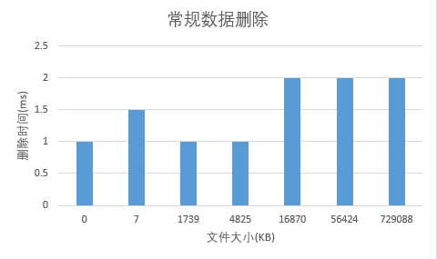
We used AOP to monitor the time that a file manager spent to delete different sizes of documents. The result indicates that the time cost of deleting task does not increase with the size of files. Above statistics also indirectly indicate that only the file node was deleted when the file was deleted. Therefore, when the data of the private directory is deleted, it is no longer protected by the sandbox. Once the terminal is lost or the attacker gets root privileges, the data on the disk is leaked.

Empty unsafe application data s
The Android system and other common file managers provide users with the "clear application data" function. Users can manage the application interface or file management to find the clear data interface. This feature can help users clear the specified directory under user data private directory. In order to study its security level. We analyzed the source code of several file managers and discovered that this data deleting function would call the underlying API of Android system when being used
statement.executeUpdateDelete()->
…->
getSession().executeForChangedRowCount()->
…->
mConnection.executeForChangedRowCount()->
…->
nativeExecuteForChangedRowCount()
It can be seen that File Manager in the "clear the application data" this function will be in the underlying call nativeExecuteForChangedRowCount() this function to delete the data in the database. By querying the Linux manual, it is found that this function does not take any mitigation measures against the data residue problem, that is, the data deleted by the function will have data residue.

pureEnc
The above analysis of different data deleting function of the Android platform, found that the vast majority of data erase operations will lead to the phenomenon of data residue. How to protect the security of the upper application data in this case becomes an urgent need to study the problem. The data lifecycle starts from the data generation until the data is deleted. A secure data protection scheme should completely cover the entire lifecycle of the data. Through the previous analysis, in the Android platform, the underlying file system can’t guarantee the safe erasure of the data. Therefore, in order to combat the inevitable existence of data vulnerabilities, we propose an Android platform application data protection technology called PureEnc. PureEnc is a data protection scheme rooted in the upper layer of the system, and does not depend on the underlying file system support, which can effectively protect the data. While protecting data, PureEnc is transparent to application developers and users and does not affect the normal use of the application. PureEnc through the hook application to read and write the file API, the data is written to disk before the automatic encryption, in order to ensure that the data will not be clearly saved to disk, so as to avoid the impact of data residual vulnerability. When reading an encrypted file, PureEnc automatically decrypts the contents of the file to ensure that it does not affect the normal use of the program.:

design
Through the above analysis, for the application, the bottom of the Android file system is insecure, untrustworthy, flash memory on the data residue problem is inevitable, the need to design a transparent application for the user-level data protection program, the security of the data in the scenario is not affected by the underlying insecurity.
Compared to modifying the Android system or upgrading the system to a more secure version, by modifying the application to get higher security is more easy to implement the program. So this article designed the PureEnc, by modifying the application file read and write interface, write the disk data encryption, to ensure that the data will not appear in a clear way on the disk, in order to deal with data residual vulnerability. For different applications using different encryption keys, the key only appears in the application's memory, immediately destroyed after use. At the same time, PureEnc supports applications that need to encrypt files to ensure that only files that need to be protected are encrypted to ensure that the application's operating efficiency is not affected. When applications that use PureEnc are uninstalled, the remaining cube on the disk is encrypted, and if the key is not available, the attacker can’t recover any useful information from the ciphertext.
In addition to actively encrypting data, PureEnc also provides mandatory secure erase for shared files. In the Android system, many applications will share data with each other, such as photographic applications will be shared in SDcard to store a folder for the photos. In this case, the use of an independent key to encrypt the data will result in the application can’t share data between the application of ease of use caused damage. For this file specifically for these files to provide mandatory security erase function, PureEnc through Hook take over the system to remove the API, delete the file before using the correct security algorithm to erase the data multiple times to ensure that as little as possible data remaining in the disk On, PureEnc architecture shown in Figure 1.

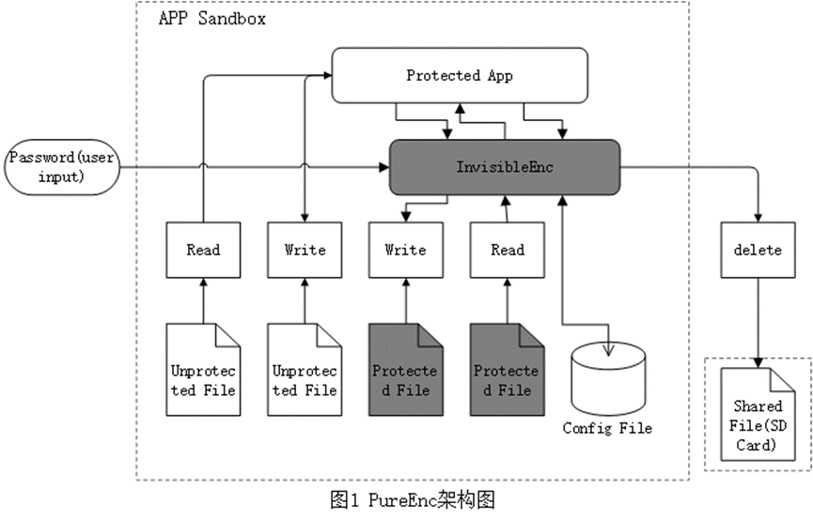

implementation
PureEnc is designed for Android application developers and should be deployed in the application during the development phase of the application. By deploying PureEnc in the code, the application can gain the ability to encrypt and read all files without requiring the application to apply for any additional privileges. For application developers, deploying PureEn only needs to add a line of code in the application's code to load our designed .SO library into the application's memory. This .SO library will automatically complete all the subsequent work of PureEnc, so it’s Is very easy for application developers to deploy. Applications installed with PureEnc is not different from other general applications in use. The user will not feel any exception, only all the data that this application written to disk has been encrypted by PureEnc.
For PureEnc, the range of files we protect is limited to those that are created or modified after the application is installed. For those files that already exist in the application installation package before the application is installed and files that will not be modified after installation, the confidentiality of these files has been compromised when the application installation package is transmitted. After the installation and protection can not only improve the security, but will increase the complexity of the deployment of this program. When PureEnc is loaded, it automatically hooks all the file write functions in the application memory space, and then changes the partial instructions of those functions to a series of jump instructions so that each time a call to those functions jumps first Go to the prepared preprocessor function. In the preprocessor function to encrypt the data, encryption will be completed after the call to the original file write function will be written on the disk. The file read function is similar to the write function. Except that the preprocessor function decrypts the ciphertext after reading it and returns the plaintext to the function caller. When a file is deleted, the key associated with the file is automatically discarded by the system, and the data remaining on the disk can’t be decrypted by anyone. On the Android platform, the vast majority of file read and write APIs rely on the write / read function in libc at the bottom, so we hook these two series of functions in our prototype system. In the experiment, through the hook of the two series of functions will be able to achieve the objectives of this article. In the process of deploying PureEnc, another aspect to consider is the selection of encryption schemes and key management.
In the process of deploying PureEnc, another aspect to consider is the selection of encryption schemes and key management.
Key management, for each of the protection of the program to install the App, App starts will require the user to enter the corresponding root key. The root key is set by the user at the first start of the App, and the root key is the basis for the system to encrypt and decrypt the file. The wrong root key will not be able to start the application. The root key exists only in memory and is immediately erased from memory immediately after use to ensure the security of the root key. For each file that is protected, the system automatically generates a different file key from the root key, ensuring the security independence between each file and between each application. Since file names can be modified, so we use the file's corresponding inode number on the disk to distinguish between different files, not the file name. As the application of the file read and write is unpredictable, each time from the file to read or write the data in the file location will change. In order to prevent the file from appearing on the disk, we use the stream password to encrypt the file to ensure that each bit of the data can be properly encrypted, we from each file corresponding to the file key to generate a key stream, the correct encryption / decryption operation is performed using the key stream according to the location of the write / read data in the file. Throughout the encryption / decryption process, the use of the root key, file key, the keystream is only present in memory, not stored on the disk. Destroyed after sued, to ensure the security of all keys. In the whole scheme, the security of the data on the file system is protected by the mature cryptographic encryption scheme. The security of the key is based on the security of the root key. Under the protection of our program, no matter how much residual data is collected by the attacker, it is not possible to restore these encrypted data to useful information. For application developers, the only thing they need to do with our solution is to load our hook framework when the application is initialized. In Android application development, only one line of code is needed to complete it. While the proposed protection program can also be re-packaged technology to protect those who do not support the source code applications.

Experiments
To be continued…

Summary
In this article we analysis the security of data erase operation in Android system and found that in the current Android system, the vast majority of data erase operations will produce data residue, may lead to data leakage. On the basis of this analysis, this paper proposes the upper level application data security scheme named PureEnc, which can effectively deal with the data residue problem. Finally, this paper will demonstrate that PureEnc does not affect the system's normal operating efficiency (to be completed).

Reference
- Baekes M，Gerling S，HammerC，et a1．AppGuard-enfordng user requirements on android apps[C]//International Confe-rence on Tools and Algorithms for the Construction and Analysis of Systems(TACAS’2013)．Rome：Springer Berlin Heidelberg，2013：543-54J. Clerk Maxwell, A Treatise on Electricity and
Magnetism, 3rd ed., vol. 2. Oxford: Clarendon, 1892, pp.68–73.
- Flash memory[OL]．[2016-5-17]．http://en.wikipedia.org/w/index php?title=Flash_memory
- Bugiel S，Heuser S，Sadeghi A R. Flexible and fine-grained mandatory access control on Android for diverse security and privacy policies[C]//Usenix Conference on Security．2013 :131—146
- scrypt[OL].[2016-3-14].http://www.tarsnap.com/scrypt.html

